“ARKLOW VIKING”

GSS No. 316631 / UL / 13 February 2014

Assured: Arklow Shipping Ltd.

ADVICE SUMMARY

UCR / Reference: | Not applicable
Date and Nature of Casualty: | 09 February 2014 – Heavy weather damage to the foredeck resulting in the flooding of the forward spaces.
Description of Damage: | Damage to wavebreak, water damage to bowthruster, CO² room, emergency fire pump and electrical equipment and panels. Loss of ropes, paint and chemicals.
Nature of Repairs: | 1.Temporary repairs require:  Steel repairs to the foredeck and wavebreak  Renewal of electrical components and emergency fire pump motor.  Replacement of water damaged safety equipment and mooring ropes.  Filling of CO² bottles and service/ test.  Two new fire doors to fit.  General cleaning.
Status of Repairs: | 1. Temporary repairs are being carried out expected to be finished on 17 February 2014.  2. Permanent repairs deferred to drydock in June 2014
Estimated Cost of Repairs: | Temporary Repairs: EUR 71,500.00  Permanent Repairs: EUR 131,500.00  Including general expenses: Yes
Survey Fee Reserve: | 22 hours to date + £ 350 expenses  Follow up 10 hours + £145 expenses  The fee estimate provided is in accordance with our Standard Terms and Conditions and is provided for guidance only. It is necessarily a budgetary estimate for time and expenses based on known and/or anticipated requirements at the time of issue, but are subject to alteration should circumstances change.
Remarks: | Has an allegation been made: Yes  Is a follow-up attendance required: Yes

“ARKLOW VIKING”

ADVICE No.1

Type of policy/instruction :- H&M
Instruction date :- 10 February 2014
Registered Owner/Manager :- Arklow Shipping Limited
Port of Registry :- Arklow
IMO number :- 9163635
Year built/GT/DWT :- 1999/ 2829/ 4940
Classification Society :- Bureau Veritas

Attending Surveyor :- Paul Hill
Contact Details :- +44 7711489246
Survey Location :- Portland, UK
Survey Date :- 10, 11 & 12 February 2014

--------------------------------------------------------

Date & Nature of Casualty:- 09 February 2014 – Heavy weather damage to the foredeck resulting in the flooding of the forward spaces.

Brief Description:-

It was reported that during the loaded voyage from Brunsbuttel, Germany to Montoir, France the vessel encountered severe heavy weather in the western English Channel.
On the night of the 08/09 February 2014 a series of unexpected waves of around 9 metres hit the foredeck. The pressure of the water caused the starboard side of the steel wave break structure to bend ripping the supporting vertical stiffeners from the foredeck. At 0105 hours on the 09 February 2014 the Chief Engineer reported to the Master that the bowthruster bilge alarm had activated.
Due to the severe weather it was unsafe at the time to send a man forward to investigate until the weather eased at 0940 hours when it was visually confirmed that the wave break had been damaged and that the resulting holes in the deck had allowed water to enter the forecastle bosun’s locker, the adjacent CO² bottle room, the paint locker and the bowthruster space.
Owners were immediately informed of the situation and the Master decided to seek shelter in Torbay while the extent of damage was ascertained. Further investigation revealed that the forward access door to No.1 hold had been deformed and that water had entered the hold as a result.
At 1907 hours on the 09 February Owners ordered the Master to proceed to the nearby port of Portland in order that the necessary repairs could be carried out.
The vessel arrived alongside berth at 0030 hours on 10 February, assisted by a harbour tug as the bowthruster was in operative.

Extent of Damage:-
Following the pumping out of approximately 150 tonnes of seawater over two days the foreward spaces could be entered in order to ascertain the extent of the damage below.
As the seawater was contaminated with paint and chemicals from the paint locker it was necessary to be pumped into road tankers and disposed of at an appropriate treatment facility in Avonmouth approximately 100 miles from Portland. A total of six tanker loads being removed.

Wave break structure
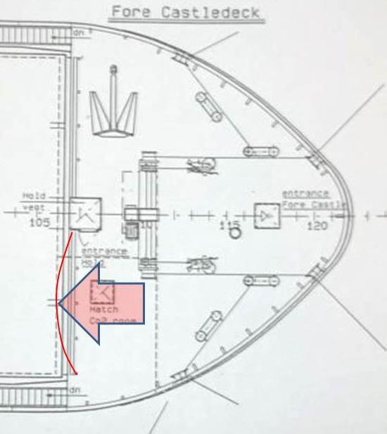
The drawing below is a plan view of the Vessel’s foredeck with the red arrow showing the wave impact and the red line showing the deformation of the wave break structure.

The entire length of the starboard side wave break structure was found to be pushed aft by approximately 600mm at the top. The four vertical stiffeners were found to be detached from the deck at the welds. The deck at the interface of three of the stiffeners was found to be fractured with holes of approximately 200 x 50mm in the steel.

No.1 hold forward access door
The watertight access door and door frame was found to be buckled with a gap of around 50mm at the bottom that prevents the door from sealing properly.

Bosun’s locker
The bosun’s locker was used to store mooring ropes, pilot ladders, dunnage, and spare hatch rubbers. All of the contents were found contaminated with paint and chemicals.
The electrical starter panel and resistance bank for the bowthruster motor was found to be saturated with seawater, paint and chemicals as well as fibres from the mooring ropes.
The electrical distribution boxes for the forward mast lights, emergency fire pump and anchor windlass/ mooring w.ere found to be similarly affected by contaminated seawater. Other equipment

in the space including lighting, ventilation trunking and fans were also found to be damaged beyond repair.

CO² bottle room
The CO² room that houses the bottles and equipment for hold flooding in the evnt of fire was found to be contaminated with seawater, pait and chemicals. The fire door that separates the room from the bosun’s locker was found to be bent in two and dislocated from its hinges, floating debris had caused several of the CO² bottle actuating valves to be opened discharging the contents of the bottles, associated pipework and control valves were found to be affected by debris.

Paint locker
The fire door to the paint locker had been dislocated and bent in a similar manner to the CO² room door. This had resulted in the paint cans and chemicals within being spread around the flooded space. The paint cans were found to be dented with lids removed and the paint mixed with the seawater and debris.

Bowthruster space
The bowthruster space was flooded with resultant damage to the bowthruster electrical motor and the electrical emergency fire pump also in the space.

Safety and firefighting equipment
The forecastle deck fire hose box and hose was found to be damaged.
The fire fighting equipment and chemical safety locker containing breathing apparatus, fire suits and associated equipment was damaged and parts of equipment missing.

Nature and Estimated Time of Repairs:-

Wave break structure
With the agreement of Class, Owners have elected to effect temporary repairs to the wave break structure by cropping the damaged vertical stiffeners, fitting doubler plates to the deck and inserting new sections of steel to the stiffeners. These to be fully welded to the satisfaction of Class with additional stiffeners being fitted as required.

Permanent repairs are deferred until the scheduled drydocking in June 2014, these will involve the cropping of the buckled steel structure and the fitting of new steel.

No.1 hold forward access door
Temporary repairs are to be effected to the door and frame in order to make the entrance water tight with permanent repairs being deferred to the dry docking. Permanent repairs will involve the fabrication and fitting of a new door frame and repair of the door.

Bosun’s locker
The bosun’s locker is to be emptied of the contaminated mooring ropes, pilot ladders, dunnage, and debris; this is being disposed of in shoreside waste skips.
The electrical starter panel and resistance bank for the bowthruster motor will require complete replacement; however this is also being deferred to dry dock with the Vessel intending to operate without the bowthruster. This will necessitate tugs being used to assist in future berthing.

The electrical distribution boxes for the forward mast lights, emergency fire pump and anchor windlass/ mooring are to be temporarily repaired in order to establish electrical power to the affected equipment, with permanent repairs being again deferred to dry dock. Permanent repairs will involve the complete replacement of electrical boxes and switching equipment.

CO² bottle room
Following cleaning and drying of the compartment the CO2 bottles will be tested by a specialist company and refilled as necessary. Function testing of the valves and associated control equipment will be carried out to the satisfaction of Class.
A new fire door will need to be fabricated and fitted before departure.

Paint locker
Contents to be emptied and disposed of, the paint and chemicals will require replacement.
A new fire door will need to be fabricated and fitted before departure.

Safety and fire fighting equipment
All damaged equipment will require replacement with new, breathing apparatus bottles will be taken ashore, tested and refilled if satisfactory.

Temporary repairs are expected to be complete on Monday 17 February 2014.

Cause of Damage:-
Owners allege that the cause of the damage was due to the vessel encountering heavy weather, with unexpected large waves impinging on the forward deck wave break structure.

Remarks:-
It is agreed that the cause of damage described above may reasonably be attributed to a casualty of the nature of that alleged.

Estimated cost of temporary repairs:-
Disposal of contaminated sea water |  | EUR 15,000
Temporary steel repairs to the deck and wave break |  | EUR 15,000
Lighting, bilge pumps temporary fix |  | EUR 5,000
Electricians labour |  | EUR 5,000
Agents fees including berth and pilotage and harbour tugs |  | EUR 10,000
Arklow engineer |  | EUR 5,000
Skips for waste removal |  | EUR 1,500
Superintendents costs |  | EUR 10,000
Removal of bow thruster motor to shore for repair |  | EUR 5,000
Estimated cost of permanent repairs:-
Replacement of fire fighting equipment |  | EUR 5,000
Replacement of emergency fire pump motor |  | EUR 1,500
Fabrication and fitting of two fire doors |  | EUR 10,000
Replacement of mooring ropes |  | EUR 30,000
Replacement of paint & chemicals |  | EUR 5,000
Estimated cost of permanent repair deferred:-
Repair/ replacement of bowthruster motor & controls |  | EUR 30,000
Renew electrical boxes |  | EUR 10,000
Permanent steel repairs |  | EUR 30,000
General services |  | EUR 10,000
Total estimated cost |  | EUR 203,000

The cost of disposal of the contaminated seawater is a guess and may be considerably more. The estimated cost will be reviewed once quotations have been received from the superintendent. For reserve purposes only we suggest a figure of EUR 210,000 to be appropriate at this time.

Cargo Damage
The vessel is carrying a cargo of bulk cement, the forward entrance door has allowed water to enter the hold but as cement absorbs water and sets the cargo damage is considered to be minimal.
We understand that cargo receivers have instructed a surveyor to attend the vessel on their behalf.

Retained on File:-
IMO Crew list
DOC
SMC
Class survey status
Masters statement
Log book extracts

Appended:-
Selected photographs

Paul Hill
Attending Surveyor

CONFIDENTIALITY: This report is confidential. It is written for the benefit of the addressee but solely for the purpose of assisting in the resolution of the issues with which it deals. It is to be used for that limited and confidential purpose only. In the event of unauthorised release, it and all records or copies of it are to be returned immediately. No reproduction nor repetition nor disclosure of any conclusion in it, nor of any information drawn from it, in whatever form, for any other purpose than that, is permitted without the specific written permission of Braemar Technical Services Ltd.

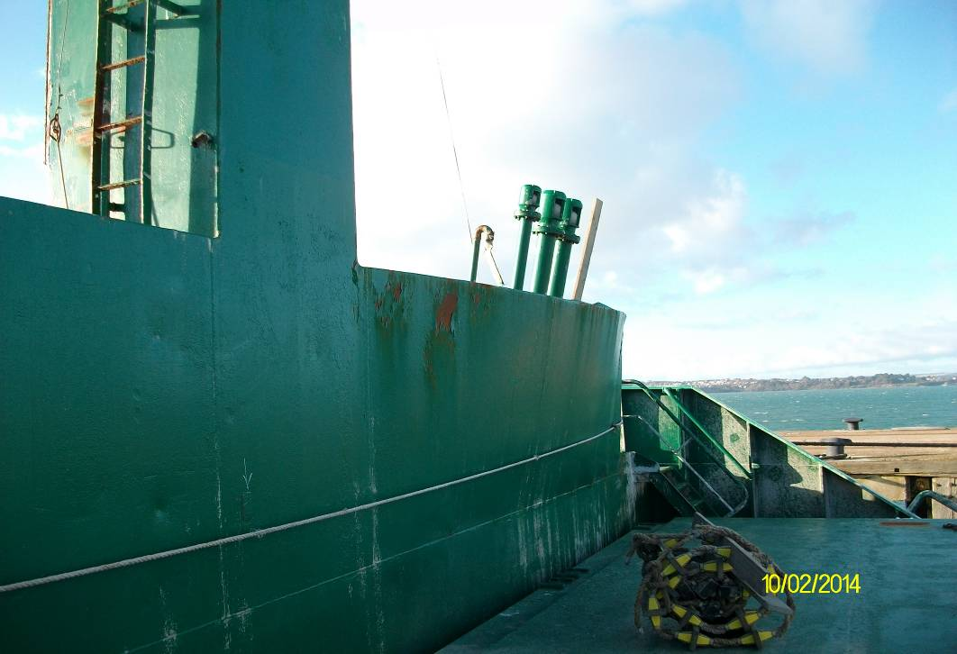
Starboard side of wave break and vent pipes bent aft

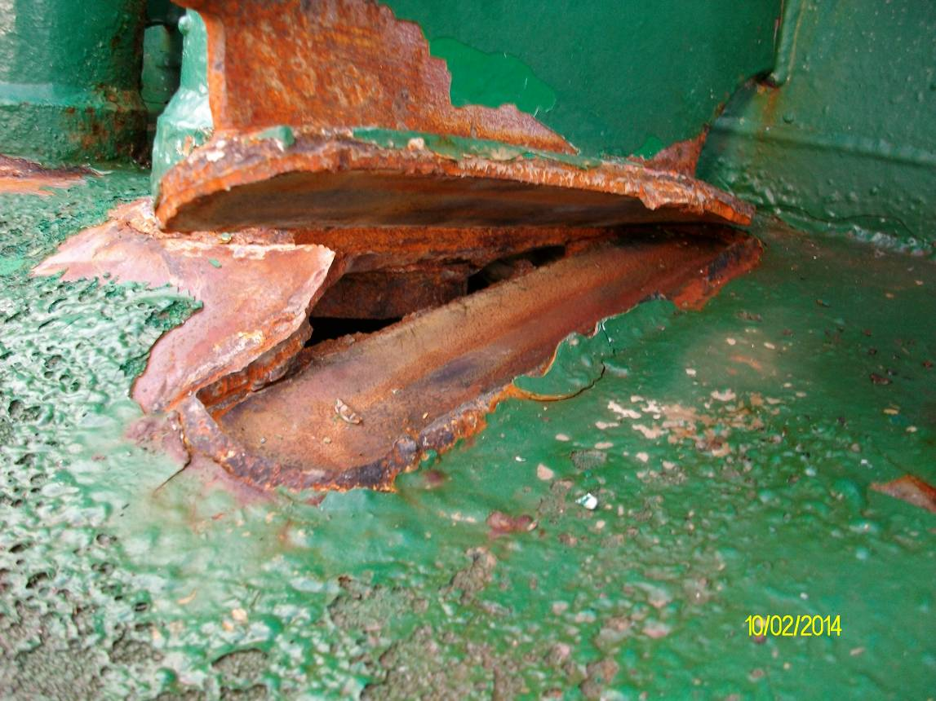
2. | One of the vertical stiffeners broken away from the deck, causing a hole in the deck, allowing sea water to flood the compartment below

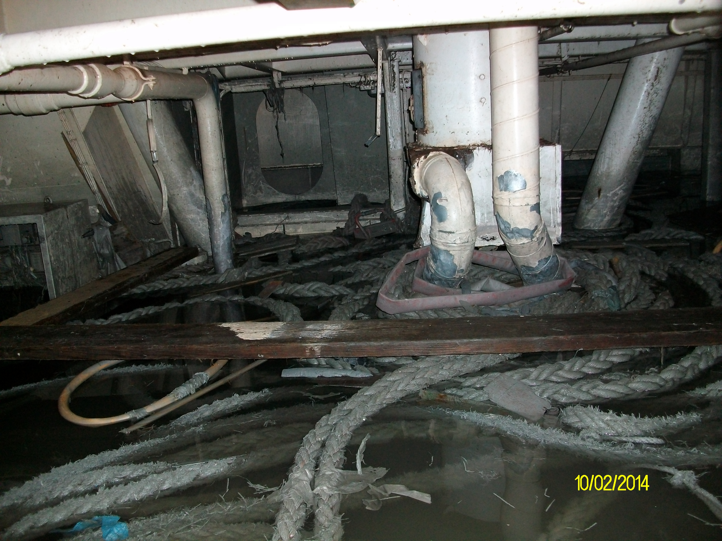
3. | The bosun’s locker flooded to about 1.2 m from the deck kead

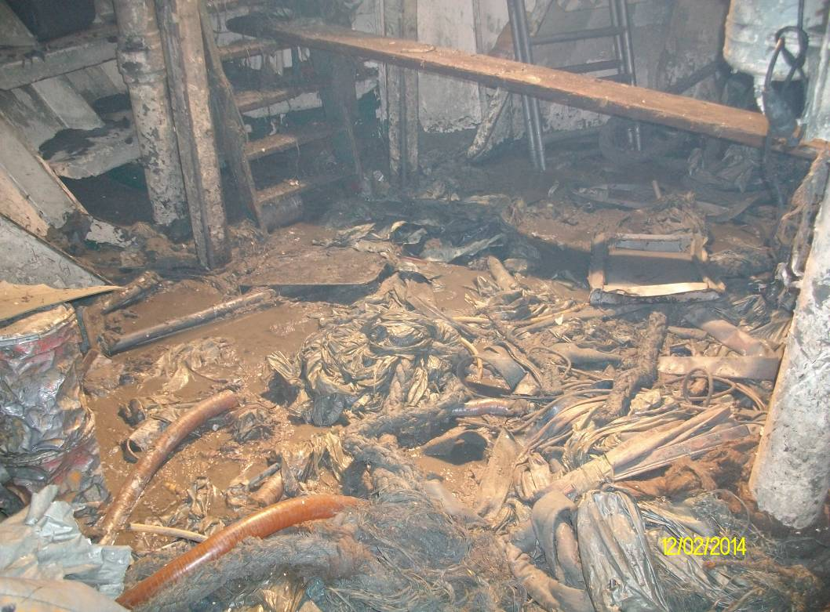
4. | The bosun’s locker following removal of the water

